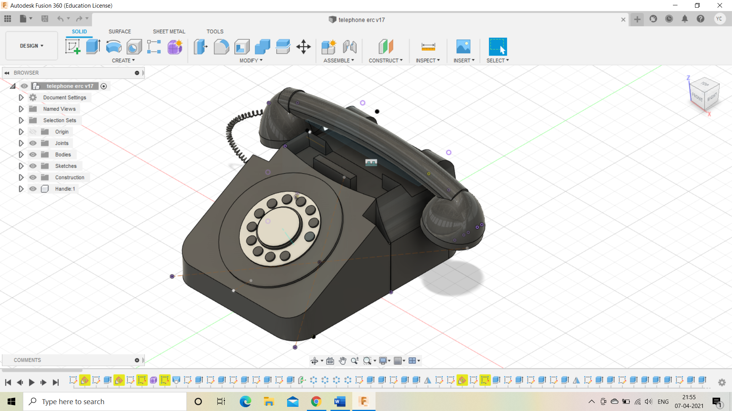750mm 318.143mm

550mm **Fillet of 75mm applied at each corner**

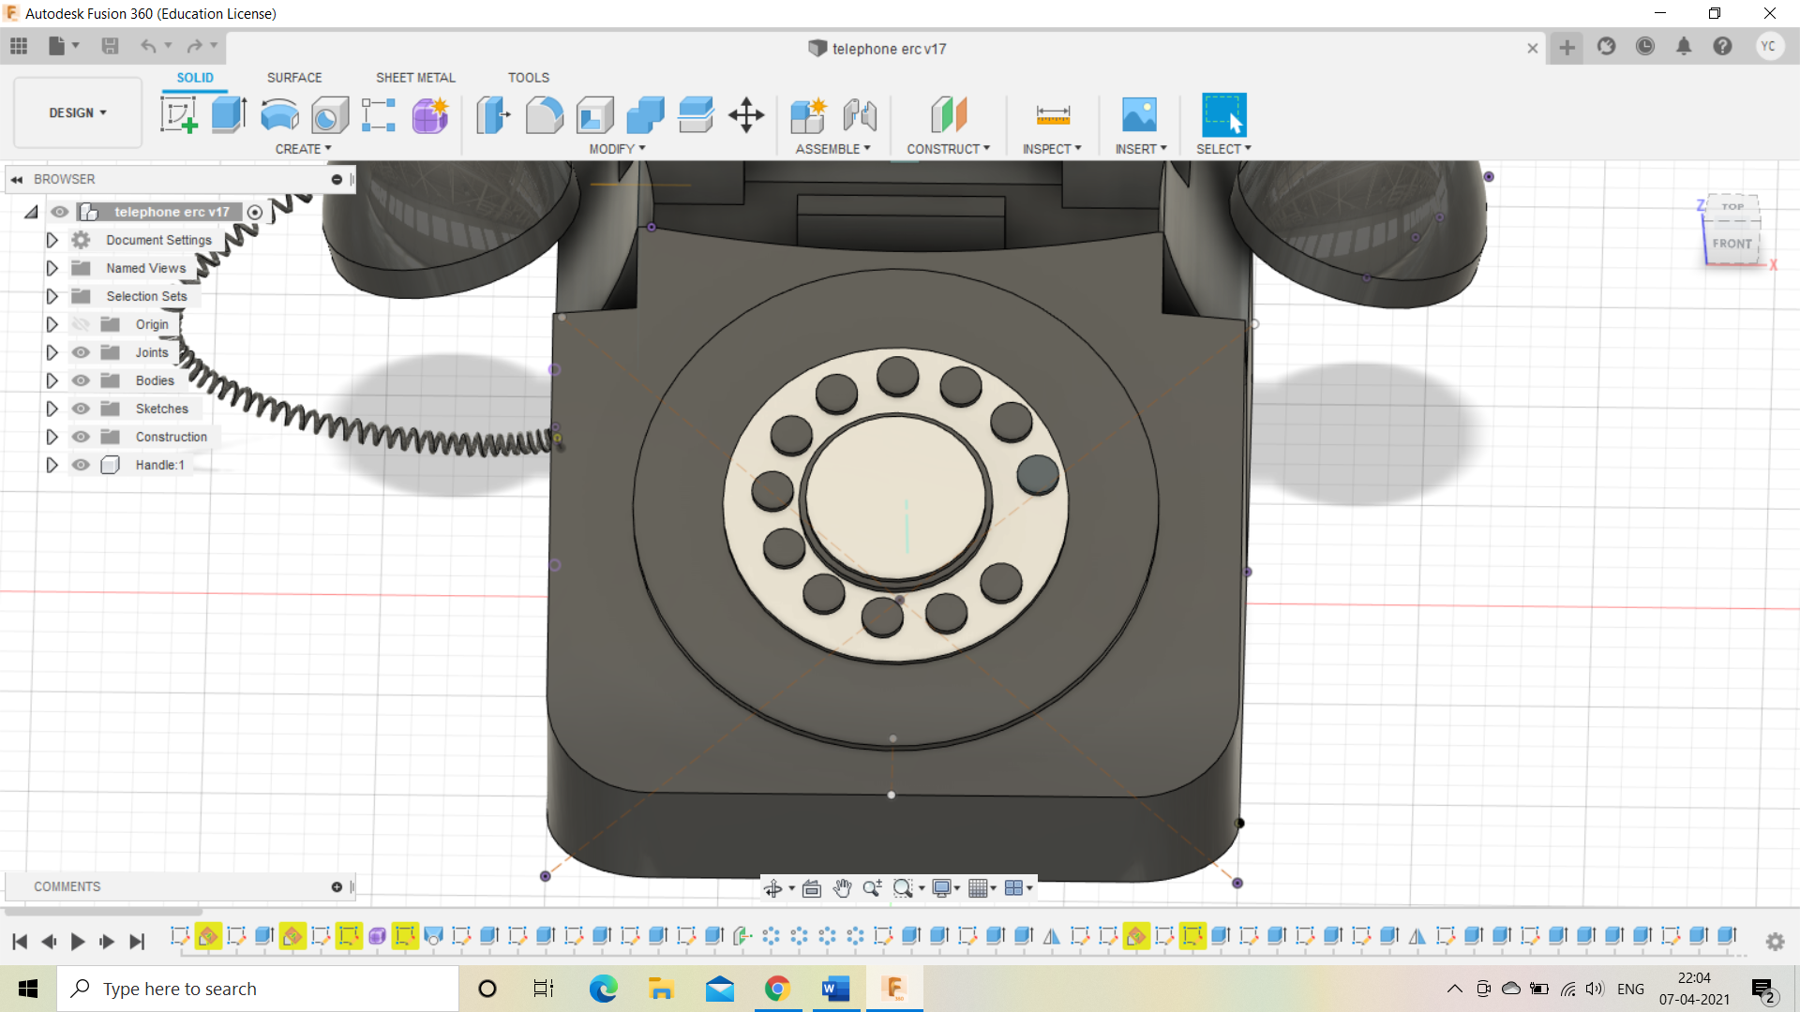190mm 125mm 65mm 330mm

550mm **Fillet of 75mm applied at each corner**

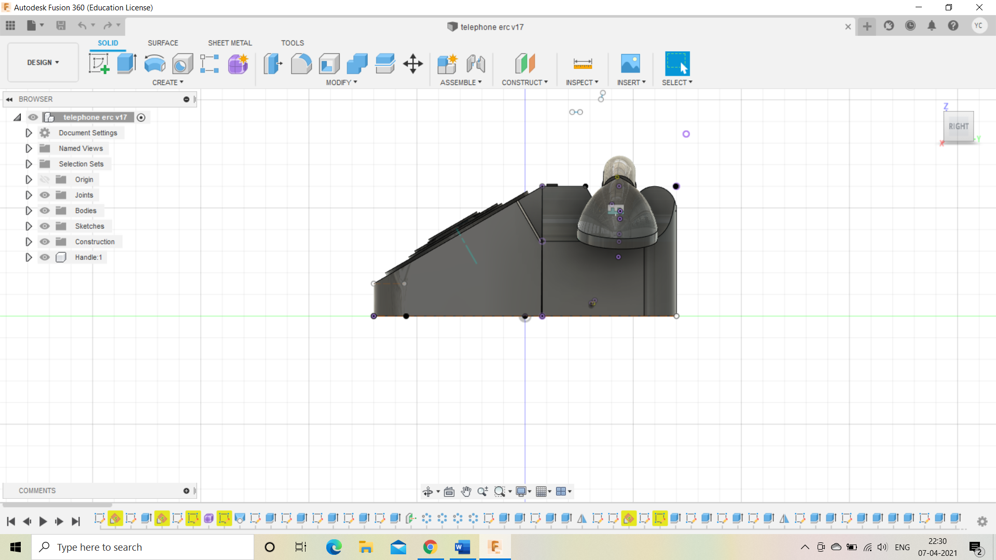 **Fillet of 75mm applied at each corner** **angle=35 degree**

439.711 mm 235.289mm

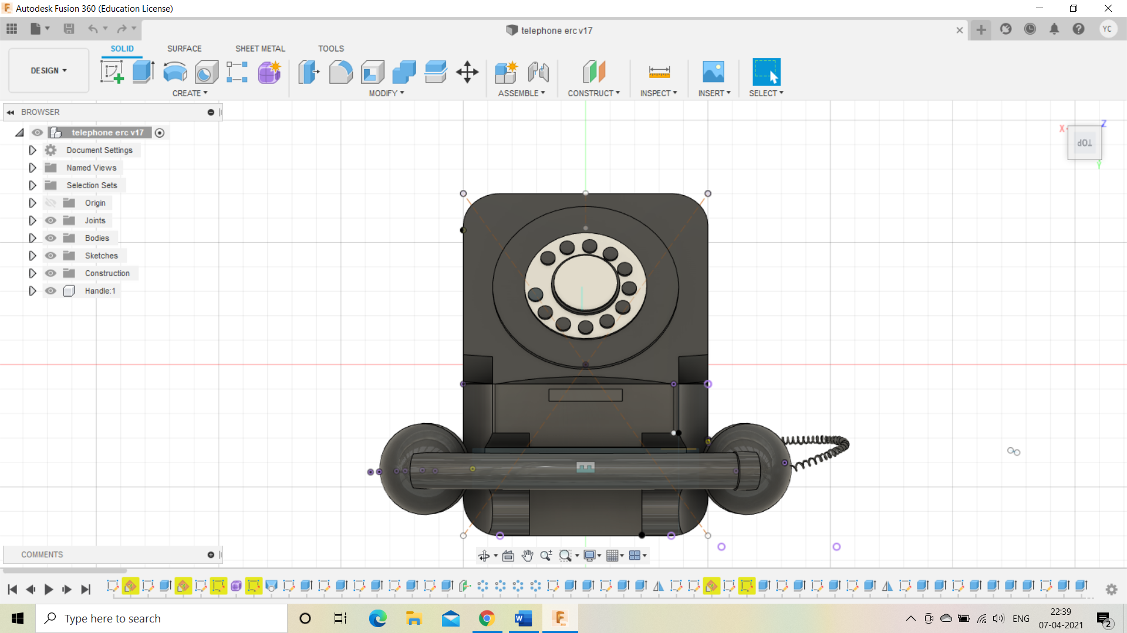150mm 25mm 100mm 60.219mm 64.391mm

**Fillet of 300 mm thickness of 10mm**

**Radius of 49.5mm and thickness of 75mm**

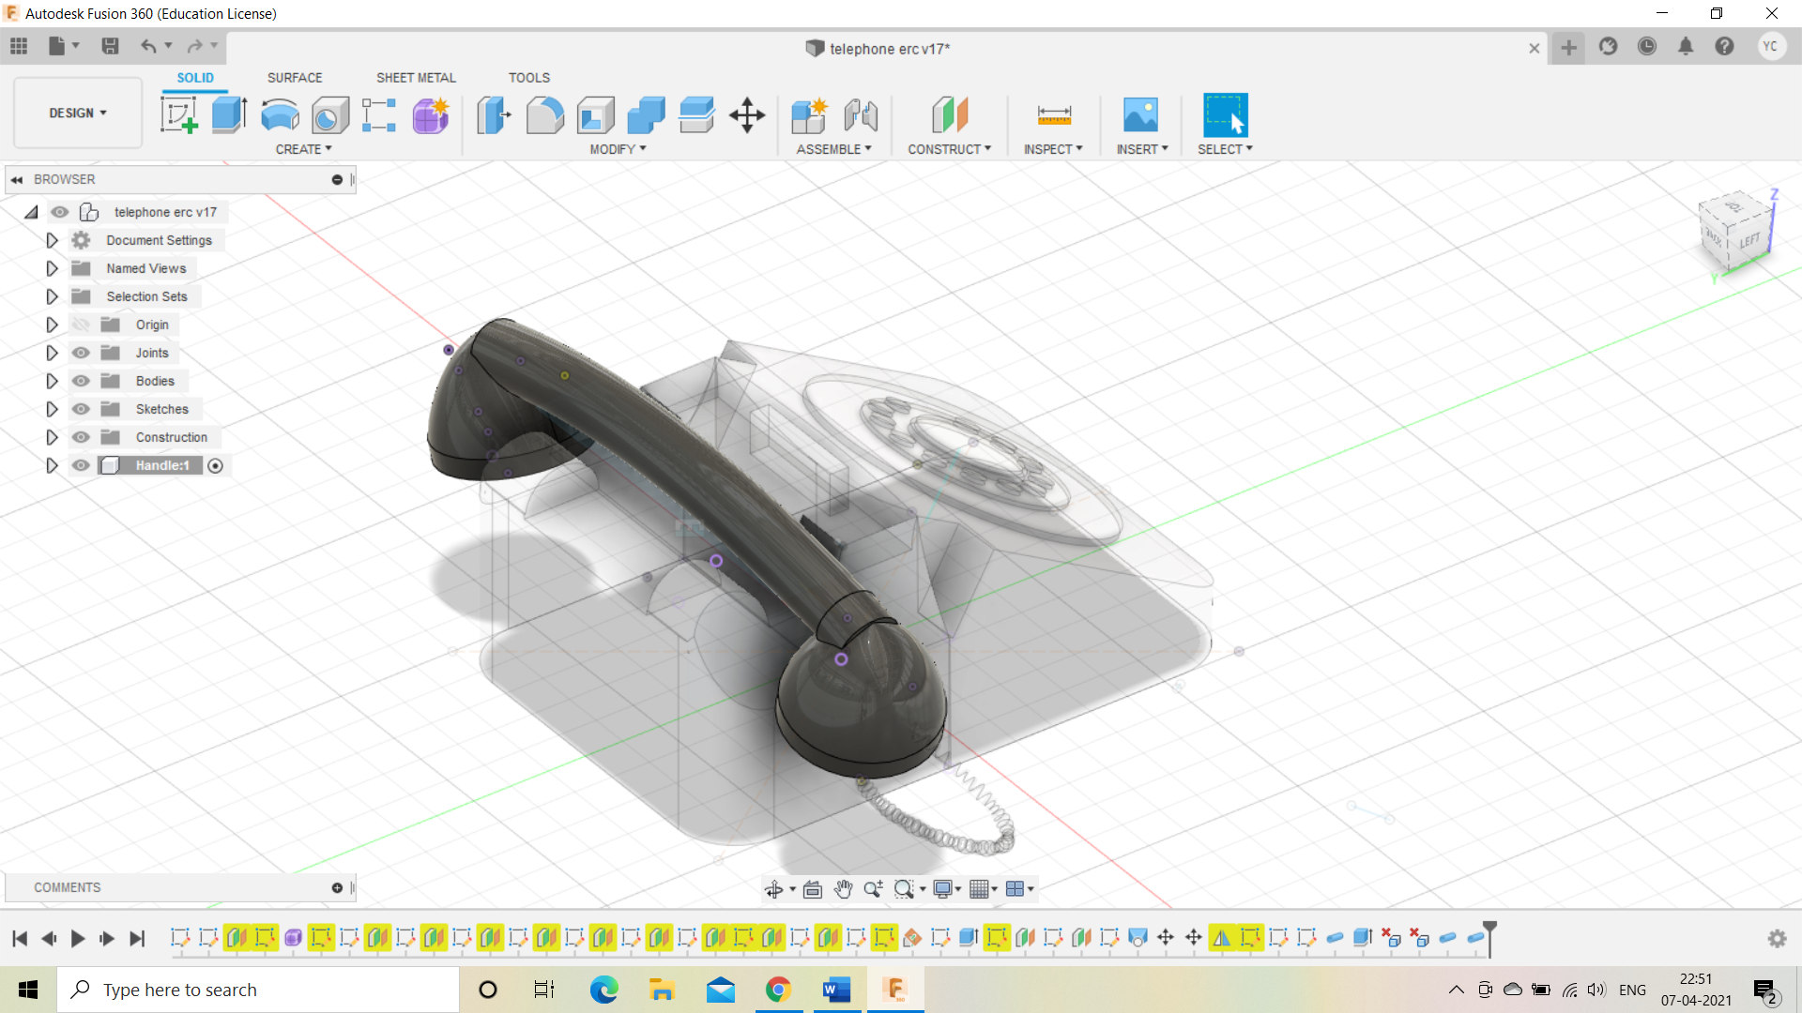 **701.389mm**

**Radius is 90.083mm**

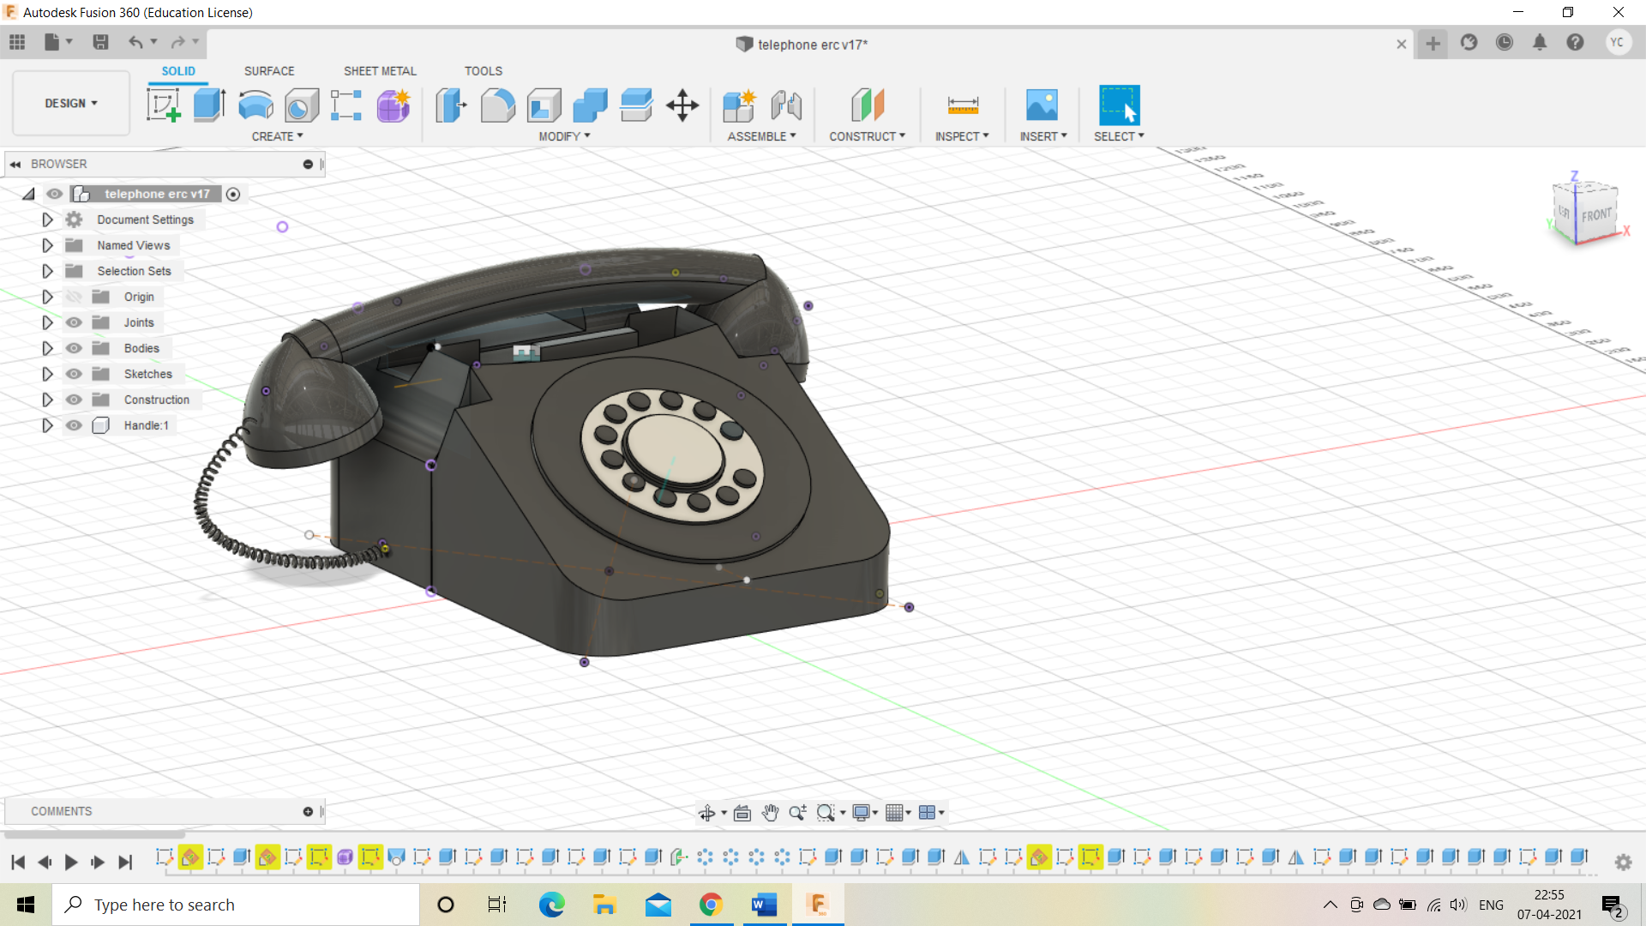 **Telephone coil with turn angle 18000 and section of 4mm and length 1mm**